**INTERNSHIP COMPLETION FORM**

This is to certify that Gavin ArenEmployee ID 530881 has successfully completed the InStep Global Internship Program (“Internship”) at Infosys Limited in **(“Creating HTTP Endpoints hosted on Azure’s Function service to alter Snowflake table data”)** under the guidance of (Marella Anji Reddy, Technology Analyst**).** The Duration of this Project was from **20/06/2022 to 12/08/2022.**

The Intern has acknowledged that the purpose of his/her Internship with Infosys Limited has been fulfilled.

For Infosys Limited.

Toai Chowdhury

Internship Coordinator

Instep Global Internship Program, Bangalore

**Place –** Bangalore

**Date** **–** 12/08/2022

I have read, understood and agree to the contents set forth in this INTERNSHIP COMPLETION FORM.

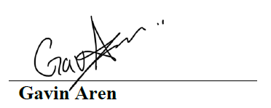

**Place –** London

**Date –** 12/08/2022